www.artnc.org

Patterned Crowns

Writer: Andrea Saenz Williams/Amy Keenan Amago
Grade Level: Pre-K
Related Big Picture Concepts: Pattern
Subject Areas: Visual Arts, Math, Music, Dance
Duration: 30 min.
Essential Question: What is a pattern?

Abstract: Students will explore pattern through observation and movement. They will create a crown with patterns and wear the crown and dance in a stomping and clapping pattern of their making.

Pre-K content is made possible by the support of:

Focus Work of Art:
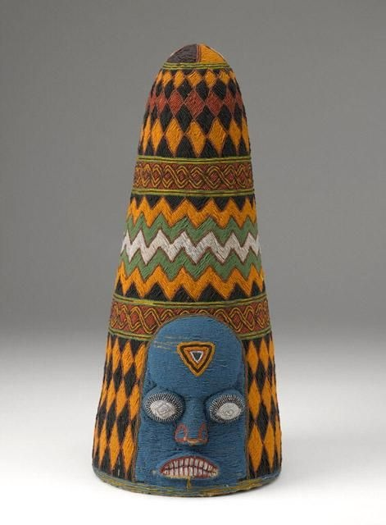
Artist unknown, Yoruba peoples, Nigeria, Beaded Crown (Adé), 20th century, glass beads, cloth, thread, and basketry, H. 18 1/2, Diam. 9 in., Gift of Mr. and Mrs. Gordon Hanes

North Carolina Foundations Correlations
Cognitive Development: CD-4, CD-5, CD-11

Student Learning Objectives
- Students will explore and identify repeating patterns.
- Students will learn about wearable art from faraway places (Africa) and create their own example.
- Students will apply knowledge of patterns through art making and dance.

Activities
Introduction/Warm-Up

- Ask students: Who is wearing a pattern today? Help define pattern by pointing out different patterns on students’ clothing.
- Introduce one of the pattern strips and have students clap as you point to each repeating shape. Repeat with different pattern strip.
- Have students “echo” clap to simple rhythms. Tell them they are clapping to a pattern and when they make their crowns, they will be making a pattern with colors and shapes instead of sounds.
- Show students one last pattern strip, and ask them to speak the shape pattern (i.e. circle, square, circle, square, circle).
- Introduce image Beaded Crown. Ask students what they see in the image.
- Share example of beadwork so that students can feel similar beads and see beads used in similar way.
- Ask students: What is a crown? Where do you wear a crown? Who wears a crown? Discuss.
- Discuss that kings in different places have worn different types of crowns. The Yoruba crown was worn long ago by a king who lived in Africa.

Focus Activity Procedure

- Demonstrate how to draw a pattern with oil pastels on strips of construction paper.
- Demonstrate how to glue the patterned strips of paper onto the “crown” paper. Students can also make a pattern with the paper strips by placing them in alternating colors.
- Demonstrate another way to create a pattern by cutting small construction paper shapes and gluing them to the background of the crown or onto the strips of paper.
- Excuse students to their seats to work.
- While students are working, walk around room and staple the straps around the back of each student’s head. Crowns can still lay flat once they have been stapled.

Closing

- Clean up.
- Gather class for closing routine and conversation. Hold up one or two of the “crowns,” and have the class clap a pattern they see on one of the paper strips.
- Invite students to wear their crowns as they clap in a pattern. Students can also be invited to dance or stomp in a pattern. If time allows, students may have a “ royal pattern parade” around the classroom, stomping or clapping while speaking a pattern. (i.e. Queens and Kings! Queens and Kings!)
- Ask students to look for art all around them at home and at school.

Assessments
- While showing the image of Beaded Crown, ask recall questions about the artwork to assess listening skills and understanding. For example: Who can tell me what this is? A crown Who might have worn this? Possible responses: a king, someone important What is it made of? Possible responses: beads, glass beads Where did this crown come from? Possible responses: far away, Africa
- Observe student work in process and in completion to assess if students were able to create repeating patterns. Look for patterns using shapes, lines and colors.
- Assess whole class understanding of pattern concept during closing by observing students’ ability to mirror stomp and clap patterns.

Resources

Vocabulary:
pattern
repeat
crown
bead

Materials:
- Assorted colors Railroad board “crown” backgrounds (pre-cut and assembled, about 9.5” wide by 17.5” tall, 1 per student, see diagram below)
- Assorted colors construction paper strips (pre-cut, about 9” long)
- Oil pastels
- Assorted colors construction paper scraps
- Scissors
- Nontoxic glue
- Optional sample of beadwork (beaded belt, purse or other)
- Globe or map to show the location of Africa
- Large strips of paper with simple patterns on them to use during introduction to lesson

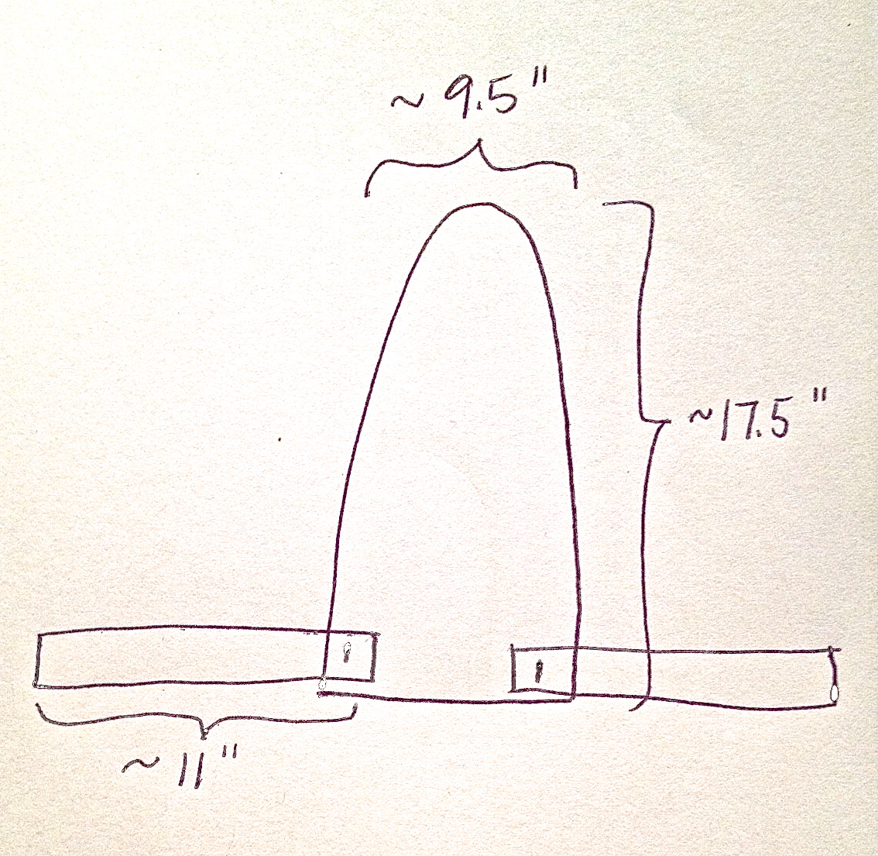
“Crown” background

Lesson Resources:

Extension Activities for Teachers
- Invite students to find patterns in classroom. Discuss how some clothing is worn for special occasions (like the crown) and some clothes are worn every day. Ask students if other things they wear could be considered art (jewelry, eyeglasses, hair clips). Why or why not?

Extension Activities for Families
- Look at family pictures of people in special clothing (a wedding dress, a prom tuxedo). Discuss clothing you wear for special occasions.

Suggested Books for Classroom Library

Brocket, Jane. Spotty, Stripy, Swirly: What Are Patterns? Millbrook, 2012. [ISBN 978-0-7613-4613-5]

Bryan, Ashley. Beautiful Blackbird. Simon/Atheneum, 2003. [ISBN 978-0-689-84731-8]

Chocolate, Deborah M. Newton. Kente Colors. Illustrations by John Ward. Walker, 1997,[ISBN 978-1-41312-866-6]

Ehlert, Lois. Feathers For Lunch. Harcourt, 1990. [ISBN 978-0-15-230550-5]

Ehlert, Lois. Lots of Spots. Simon/Beach Lane, 2010. [ISBN 973-1-44240-289-8]

Kuskowski, Alex. Super Simple African Art: Fun and Easy Art from Around the World. ABDO, 2012. [ISBN 973-1-61783-210-9]

Morris, Ann. Hats, Hats, Hats. Photographs by Ken Heyman. Lothrop, 1989. [ISBN 978-0-688-06338-2]

Pluckrose, Henry Arthur. Pattern. Childrens Press, 1995, 1994. [ISBN 973-0-329-56924-2]

Swinburne, Stephen R. Lots and Lots of Zebra Stripes: Patterns in Nature. Boyds Mills, 2001, 1998. [ISBN 978-0-329-59955-3]

Examples of Successful Student Outcomes
